Fair and Transparent Blockchain based Tendering Framework - A Step Towards Open Governance

Abdul Muneem Khan, K152897

**Why We Need Open Governance:**

As society’s values have shifted, so have expectations of government shifted from the traditional model to something commonly referred to as ‘open governance’. We take open governance to mean a concept, which encourages and facilitates openness, accountability, and responsiveness to citizens.

These technologies enable access to both the data and to engagement activities between citizens and government. Blockchain can play important role in Open Governance, as potentially a vital building block to realising open and transparent government activities.

**Steps Involved:**

*This image has copied from research paper...*

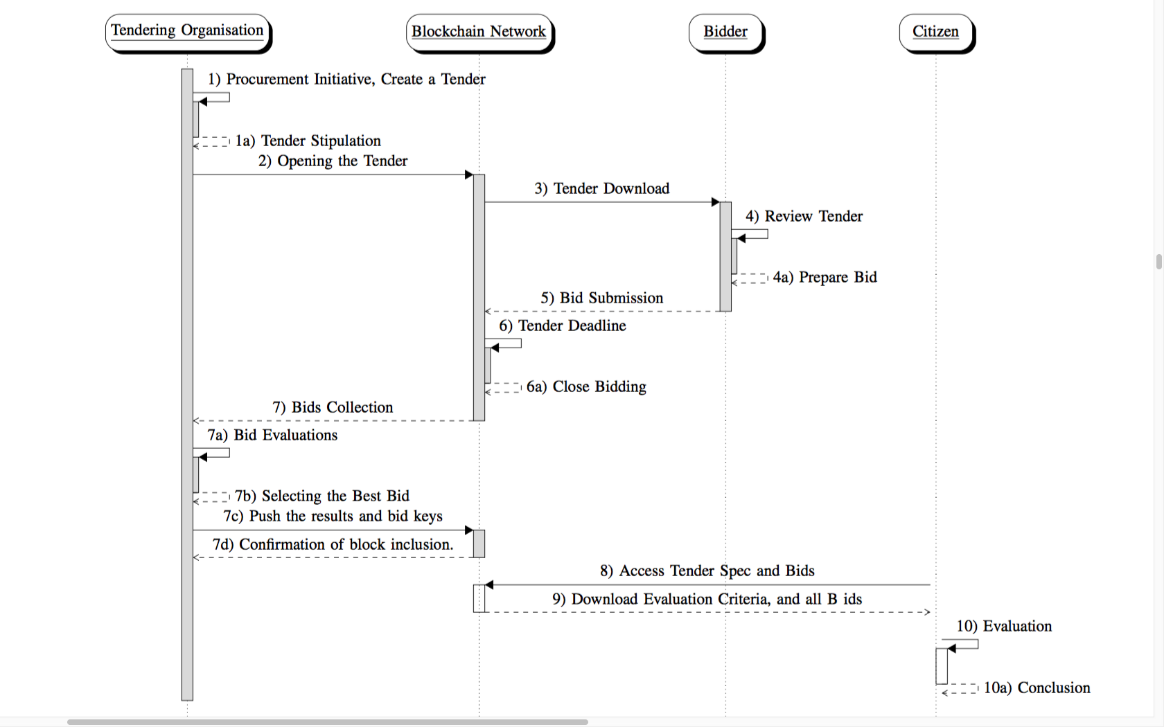

Crucial thing is smart contract:

1. Government release the tender(immutable)

2. Bidder download tender

3. Bidder review the tender and set a bid

4. Push bid (signing is important)

5. Bidding process close when time-limit end.

6. Government download bids, and evaluate it

7. Government push the evaluation result to blockchain

8. Citizen can review bids

9. Citizen can download and run evaluation for transparency

**Implementation Algorithms:**

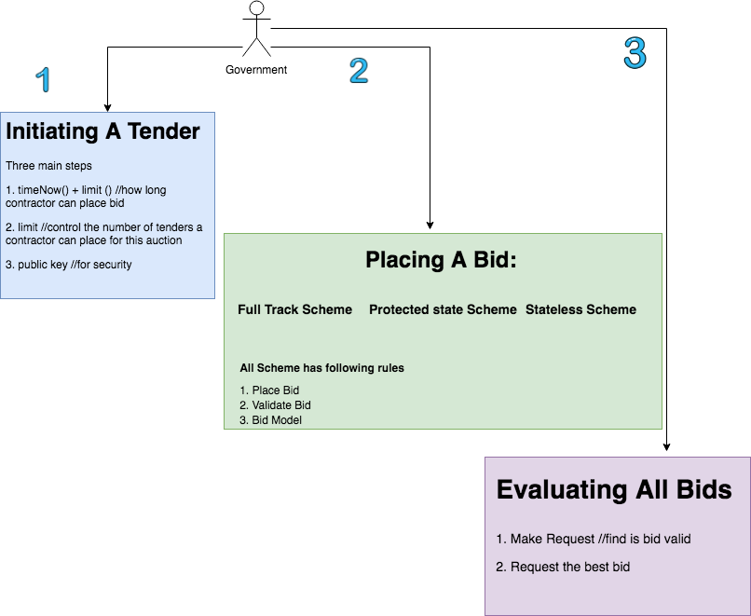

**Security and optional requirement:**

1. The tendering organization can not change the tender once it will be placed on blockchain.

2. Tender organization can not read bid, till bidding process is active.

3. Bidder can not change the bid.

4. Bidder can not see who else has placed a bid

5. Miner will not effect mining process

**Benefits:**

Traditionally it has been difficult to build a transparent governance model. This was because it required an investment of both time and money from all stakeholders, especially the citizens. With the increasing adoption of e-government and open government initiatives, public opinion is in favour of developing innovative solutions that can increase openness and transparency in government activities with minimum cost to citizens. For citizens to be involved in monitoring the governance activities, they need efficient tools and intuitive assessment that gives clear results. To build such an environment, blockchain and smart contracts show great potential.

**Conclusion:**

The main objective of the paper was to show that the tendering scheme can be made fully open, autonomous, fair and transparent using smart contracts. To this end, it was successful. There are two future research directions,

1) build additional government services on blockchains to increase openness and transparency

2) enhancing the smart contract platform to be more feature rich, autonomous and supporting secure distributed execution.

**Deliverable:**

1) Implementation of Blockchain (may on Java or Ethereum)

2) For securing purpose, use signing and encryption

3) Create panel for different stakeholders

4)Create normal database for other information (signing info etc).